Atal Bihari Vajpayee Vishwavidyalaya, Bilaspur
Course Name: MCA 3rd
Project Name: Indian Medicine Recommendation Chatbot using Machine Learning
Session: 2025-26



Guided By:
Dr. Rashmi Gupta
Submitted By:
Vikas Dewangan, Ankit Dubey,
Priyanka Sahu, Suman,
Gitesh Kumar, Rajkumar Sahu,
Rajvir Singh, Khushi Dansena,
Himani Shrivas, Shruti Bargah

Role | Name | Work
Coding | Suman | Model Training
Coding | Ankit Dubey | App Development
Coding | Rajkumar Sahu | App Development
Coding | Rajvir Singh | Module Selection and Comparison
Coding | Khushi Dansena | Module Selection and Comparison
Documentation | Vikas Dewangan | Abstract, Introduction, Problem Statement
Documentation | Priyanka Sahu | Objective
Documentation | Shruti Bargah | Database Description
Documentation | Gitesh Kumar | Methodology, Algorithm, Technology
Documentation | Himani Shrivas | Implementation, Conclusion

Abstract

The objective of a Medicine Recommendation System is to provide suitable medicine suggestions based on a user’s symptoms using medical data and intelligent techniques. In this project, a Medicine Recommendation Chatbot is developed using Machine Learning and Natural Language Processing (NLP) to analyze user-provided symptoms and recommend the top five relevant medicines.
The system utilizes an Indian Medicine Dataset containing detailed information such as medicine names, compositions, descriptions, side effects, and pricing. NLP techniques are applied to preprocess user input, and similarity-based methods are used to match symptoms with relevant medicines from the dataset.
The chatbot offers a user-friendly conversational interface that delivers quick and structured medicine information to enhance medical awareness. This system is designed for informational purposes only and does not replace professional medical advice.
Keywords: Medicine Recommendation System, Chatbot, Natural Language Processing, Machine Learning, Indian Medicine Dataset

Introduction

In today’s rapidly evolving healthcare environment, people increasingly seek quick and reliable information about common illnesses and appropriate medicines. Due to the heavy workload on hospitals and medical professionals, users may not always receive immediate guidance for minor health issues. To address this gap and make basic medical information more accessible, a healthcare chatbot serves as an effective solution. Such a system can provide instant responses, guide users interactively, and enhance public awareness by offering essential knowledge about symptoms and their possible treatments.
The use of an Indian Medicine Dataset significantly enhances the functionality of the chatbot. This dataset contains structured information on diseases, symptoms, medicines, dosage patterns, side effects, and other crucial medical details. Since the dataset is based on medicines commonly available in the Indian market, the chatbot becomes more practical and relevant for local users. It ensures that the system delivers meaningful recommendations aligned with real-world medical usage in the Indian context.
The primary objective of the chatbot is to offer symptom-based medicine recommendations through a simple conversational interface. When a user describes a health concern, the chatbot processes the input, matches it against the dataset, and suggests suitable medicines along with basic precautions and general dosage guidelines. The system is intended solely for educational and informational purposes and is not a substitute for professional medical advice.
Overall, this chatbot aims to provide a convenient, user-friendly, and informative platform that helps users understand their symptoms and learn about commonly used medicines.

Problem Statement

The objective of this project is to develop an intelligent system that recommends appropriate medicines based on a given disease or symptom. The system should accurately analyze the user input, compare it with the existing medical dataset, and generate the most relevant medicine suggestions.

Problem Description

This project aims to design a medicine recommendation system that provides suitable medicine options when a user inputs the name of a disease or symptom. The system processes the input, searches the pre-defined medical database, and identifies medicines associated with that disease. By automating this process, users can quickly obtain medicine suggestions without manually searching through complex medical information. The system is designed to deliver fast, reliable, and structured output based on the stored dataset.

Input and Output Format

Input: Disease name / Symptom
Output: Recommended medicine name

Objectives

1. User Input Understanding (NLP-Based Interpretation)
Objective: To correctly interpret user-provided symptoms or queries written in natural language.
Approach:
- Text preprocessing: lowercasing, punctuation removal, tokenization, stopword removal, stemming/lemmatization
- Entity extraction & intent detection: identifying entities like symptoms, severity, and duration
- Synonym & spelling normalization: handling equivalent terms like “fever”
- Context retention: understanding multi-turn conversations using previous messages
Tools: Cosine Similarity, Large Language Models (LLMs), Text Combination Techniques, TF-IDF Vectorization.

2. Relevant Medicine Recommendation from Dataset
Objective: To match the user’s symptoms with disease–medicine records in the dataset and provide accurate medicine recommendations.
Approach:
- Symptom-to-disease mapping using semantic similarity
- Ranking medicines using cosine similarity or vector scoring
- Providing clear explanations for each recommendation
Tools: Pipeline-based Bi-gram Module, Similarity Ranking Algorithms.

3. Disease → Symptoms → Medicine Mapping
Objective: To create a structured, normalized mapping that logically connects diseases, symptoms, and recommended medicines.
Approach:
- Dataset normalization with unique disease IDs
- Handling many-to-many relationships (symptoms ↔ disease ↔ medicine)
- Manual validation using trusted medical references

4. Simple and User-Friendly UI (Web/App/Console)
Objective: To design a clean, responsive, and intuitive interface that allows non-technical users to interact with the chatbot easily.
Approach:
- Clean UI with clear instructions and readable recommendations
- English language toggle
- Chat-style interface with quick-reply button options
- Privacy measures ensuring no unnecessary personal data is stored
Tech Stack: Streamlit for rapid UI development and deployment.

5. Dataset Cleaning, Preprocessing & Model Training
Objective: To build a high-quality dataset and a robust ML/NLP pipeline capable of delivering reliable recommendations.
Approach:
- Data cleaning: removing duplicates, handling missing values, normalizing medicine names
- Text preprocessing: tokenization, lemmatization, vectorization
- Feature engineering: symptom frequency, co-occurrence patterns
- Model training:
  - Similarity-based retrieval models
  - Fine-tuning Sentence-BERT for semantic understanding
- Validation & deployment optimization
Tools: Pandas, Scikit-learn, Gensim, Transformers, Sentence-BERT.

Dataset Description

The Indian Medicine Dataset used in this project contains structured information about medicines, their composition, pricing, usage, side effects, and drug interactions. This dataset plays a critical role in enabling the chatbot to provide accurate top-5 medicine recommendations based on user symptoms.

1. Dataset Columns

Column Name | Example Value | Explanation
sub_category | Human Insulin Basal | Indicates the medicine category/type.
product_name | Human Insulatard 40IU/ml Suspension for Injection | Name of the medicine product.
salt_composition | Insulin Isophane (40IU) | Chemical composition or active ingredient of the medicine.
product_price | ₹133.93 | Price of the medicine in Indian rupees.
product_manufactured | Novo Nordisk India Pvt Ltd | Manufacturer of the medicine.
product_description | “Human Insulatard is used to improve blood sugar control…” | Brief description and usage information.
side_effects | Hypoglycemia, Injection site reactions, Weight gain… | Common side effects of the medicine.
drug_interactions | {"drug": ["Captopril", "Enalapril", ...]} | Other drugs that may interact with the medicine.

2. Dataset Size
- Total Rows: 195,605
- Total Columns: 8

3. Data Cleaning & Preprocessing
To ensure accuracy and high-quality recommendations, the following cleaning steps were applied:

i) Missing Values Handling
- Checked for null fields in description, side effects, drug interactions.
- Missing entries were:
  - Removed if critical (e.g., missing product_name or composition).
  - Filled with placeholders if non-critical (e.g., “Not Available”).

ii) Duplicate Removal
- Removed medicines with identical:
  - product_name
  - salt_composition
  - manufacturer
- Duplicates can lead to biased recommendation scoring.

iii) Outlier Handling
- Outliers in pricing (e.g., ₹0 or extremely high prices) were detected.
- Suspicious entries were:
  - Removed
  - or replaced with median pricing values of the category.

iv) Text Normalization
Important for NLP-based matching:
- Converted text to lowercase
- Removed:
  - punctuation
  - extra spaces
- Standardized spelling variations
- Normalized synonyms (e.g., “inj.” → “injection”, “tab” → “tablet”)

v) Data Type Conversion
- Converted product_price values (₹133.93) to numeric float for sorting/filtering.
- Converted drug_interactions from JSON-like string into Python dictionary objects for easier access.
- Ensured proper encoding for special characters (₹ symbol).

5. Importance of This Dataset for Chatbot
This dataset helps the chatbot:
- Understand medicine composition
- Retrieve medicine usage information
- Display pricing
- Warn users of side effects
- Show drug interactions
- Recommend top-5 medicines using similarity algorithms

System Architecture
Start
Take Input
Input Matches
Retrieve Output
Medicine
Database
Disease
Not

Methodology

Step 1: User provides symptom input.
Step 2: NLP text processing is performed.
Step 3: The model searches for similar symptoms.
Step 4: Matching medicines are fetched from the dataset.
Step 5: The chatbot returns results in a conversational format.

Algorithms

1. Begin
2. Enter the disease name.
3. Compare the disease name with the database
4. If disease is match with the database the display the medicine accordingly.
5. If disease name not found the display the “Not Found”
6. End

Techniques Used

- NLP:
  - Cosine Similarity
- ML Model:
  - Pipeline Modules (Standard TF-IDF (Unigrams), TF-IDF Bigrams, TF-IDF N-grams, LLM Semantic Scoring.
  - Similarity Matching (Cosine Similarity)
- Chatbot Framework:
  - Streamlit

Implementation

1. Model and Dataset Initialization
- When the application starts, the system loads the Indian Medicine Dataset.
- A confirmation message is shown on the UI:
“Medicine Recommender Model loaded successfully! Dataset size: 195605 records.”
- This ensures the model is ready for use and all medicine records are indexed for similarity matching.

2. User Interface (Streamlit Implementation)
The UI displayed in the screenshot is built entirely using Streamlit, chosen because of its simplicity, interactivity, and Python integration.
Key UI features:
- A clean title section: “Health AI: Medicine Recommender”
- A text input box where the user enters symptoms or medicine requirements
- A search button: Find Medicines
- Modern icons and layout for a professional appearance
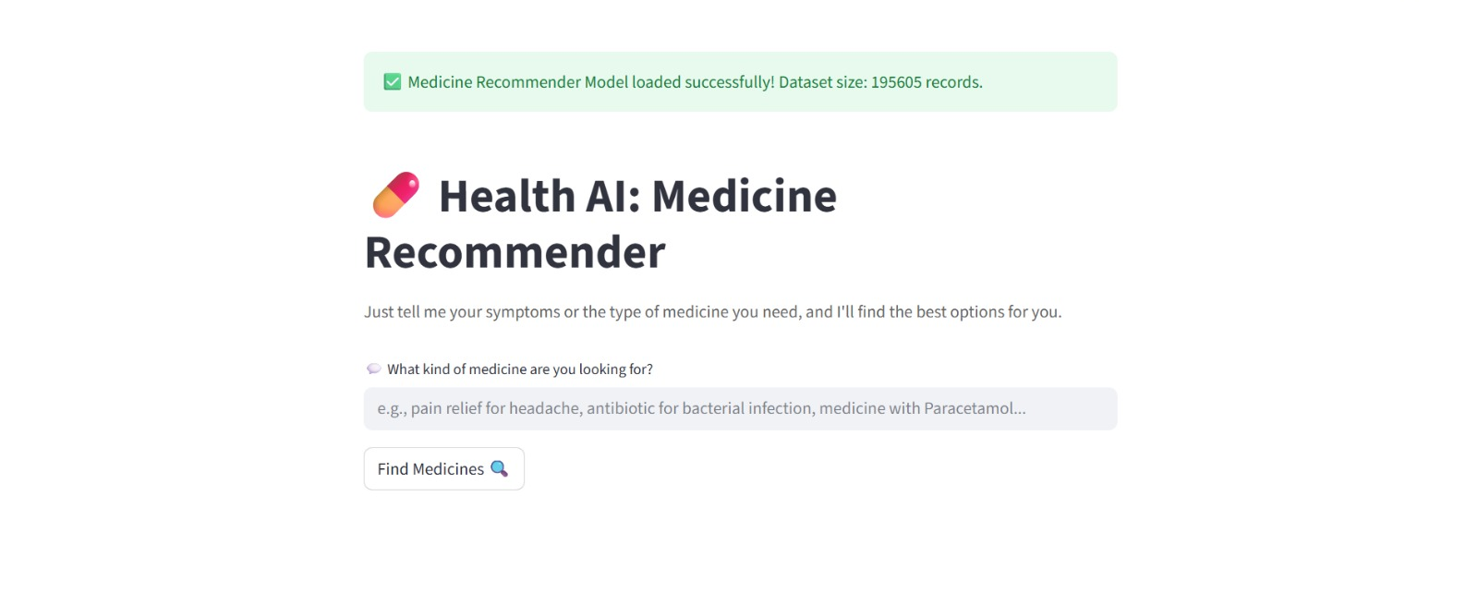
The Streamlit app updates instantly and provides real-time responses.

3. User Input Handling
When the user enters symptoms (e.g., “fever and body pain”) and clicks Find Medicines, the backend performs:
- Lowercasing
- Tokenization
- Spelling correction
- Synonym mapping
- Stopword removal
- Vectorization using TF-IDF or embeddings
This prepares the text for similarity matching.

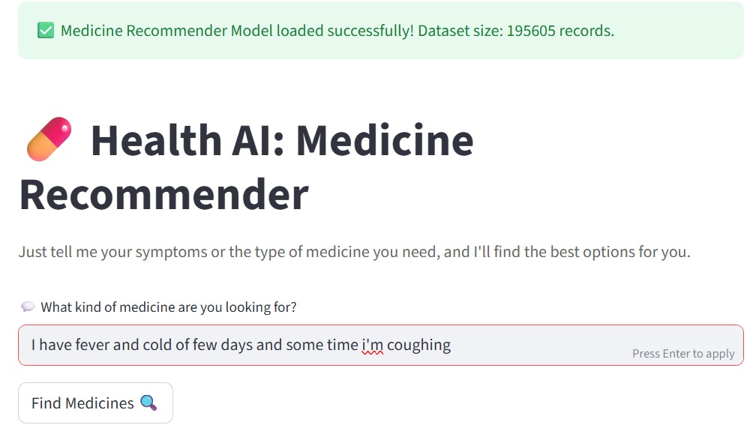
4. NLP Model Processing
Steps:
- User input is compared with dataset symptom entries.
- Text is converted into vectors using:
  - TF-IDF (unigrams, bigrams, n-grams)
  - Semantic embeddings
- Cosine Similarity is computed between user query and dataset vectors.
- The most relevant disease or symptom entries are identified.
This process ensures that the system understands natural language queries and finds the closest medical match.

5. Medicine Retrieval Logic
Once the model identifies matching symptoms/diseases:
- The corresponding medicine names are fetched
- Medicines are ranked based on similarity score
- Additional fields retrieved include:
  - Description
  - Category
  - Dosage
  - Side effects (if available)
Finally, all results are prepared for display in a clean conversational format.

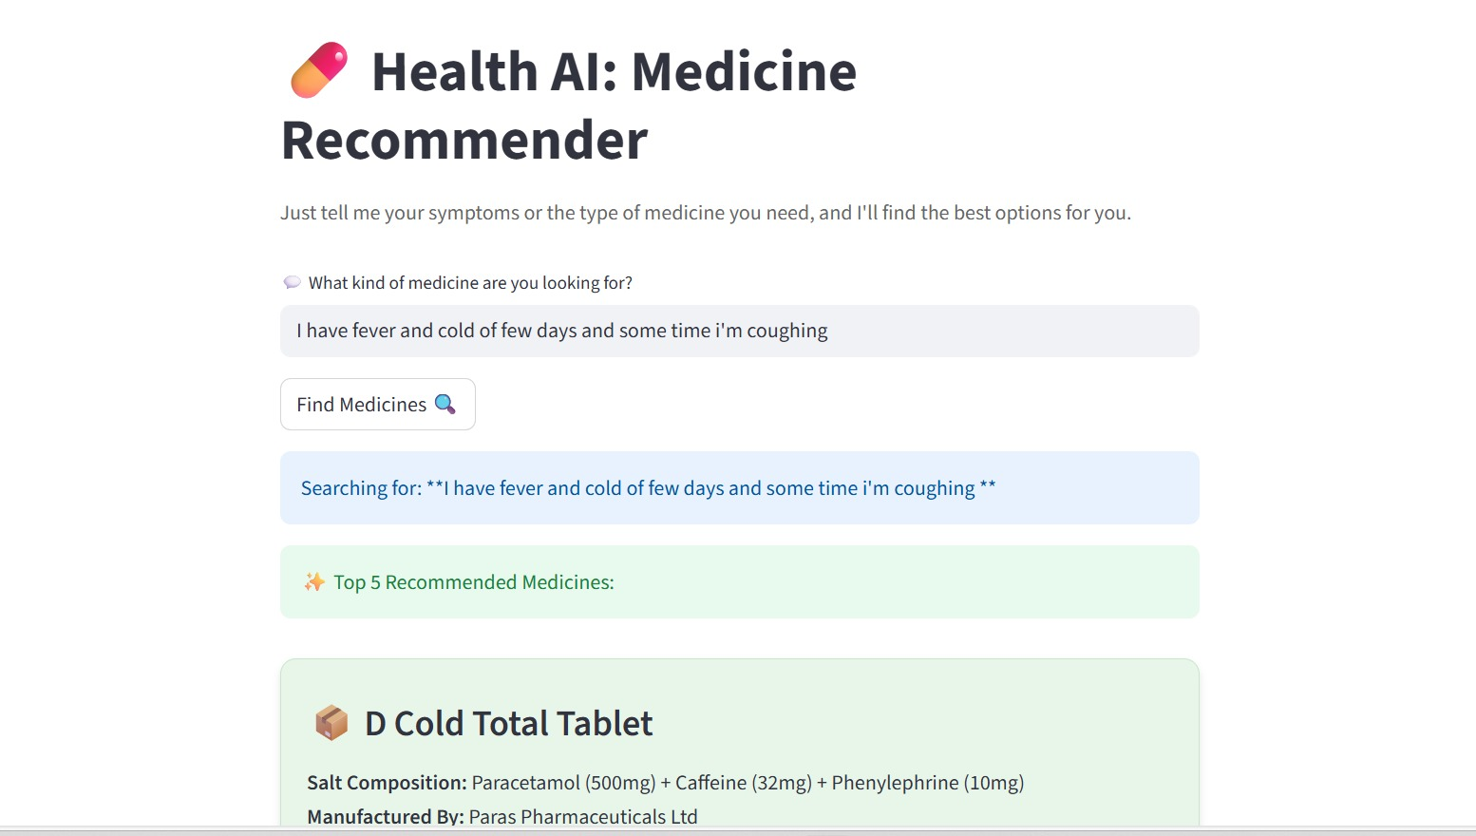

6. Conversational Response Generation
The chatbot returns results in a human-friendly message style, such as:
- “Based on your symptoms (fever, body pain), the most suitable option is Paracetamol 500 mg.
Common use: reduces fever and pain.
Side effects: nausea (rare).”
A disclaimer is also included indicating the system is not a substitute for medical advice.

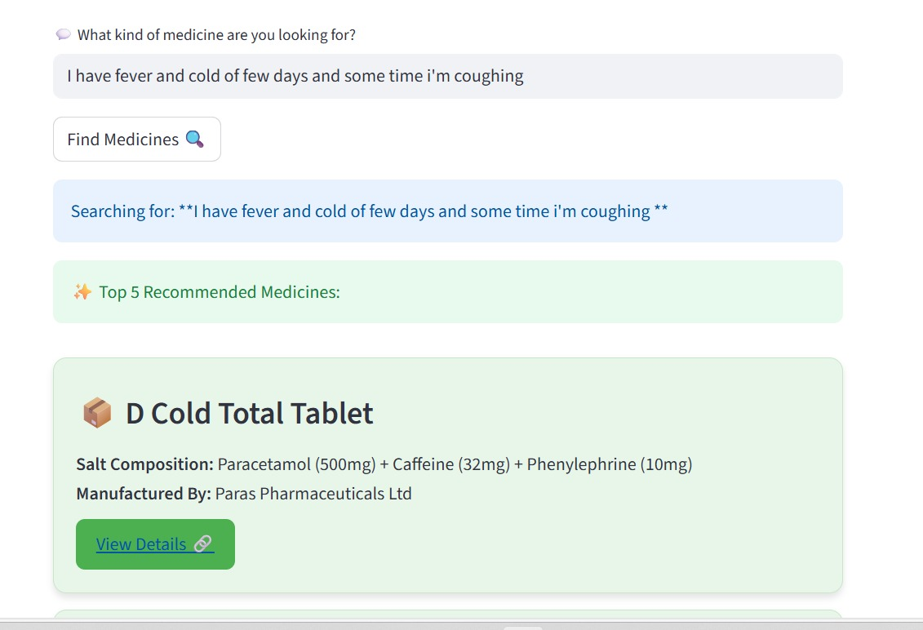

Module Testing

PIPE LINE 3 Module comparison Module (1. Standard TF-IDF (Unigrams), 2. TF-IDF with Word Bigrams, 3. TF-IDF with Character N-grams) :-

MODULE/PIPELINE: 1. Standard TF-IDF (Unigrams)
1. P 500 Tablet Relevance Score: 0.1809
2. P 500 Tablet Relevance Score: 0.1809
3. P 500 Tablet Relevance Score: 0.1809

MODULE/PIPELINE: 2. TF-IDF with Word Bigrams
1. Rasalect 0.5 Tablet Relevance Score: 0.0864
2. Rasalect 0.5 Tablet Relevance Score: 0.0864
3. Rasalect 0.5 Tablet Relevance Score: 0.0864

MODULE/PIPELINE: 3. TF-IDF with Character N-grams
1. P 500 Tablet Relevance Score: 0.1084
2. P 500 Tablet Relevance Score: 0.1084
3. P 500 Tablet Relevance Score: 0.1084

FINAL COMPARISON (Average Relevance Score of Top 3 Suggestions)
1. Standard TF-IDF (Unigrams) : Average Score = 0.1809
3. TF-IDF with Character N-grams : Average Score = 0.1084
2. TF-IDF with Word Bigrams : Average Score = 0.0864
4. LLM Semantic Scoring (NEW & BEST) : Average Score = 0.1000

BEST MODULE: Standard TF-IDF (Unigrams)
HIGHEST AVERAGE SCORE: 0.1809

Result

ACCURACY TEST: Top-5 Recommendation Relevance Check
1. Product: P 500 Tablet
Similarity Score: 21.54%

2. Product: Paracetamol 500mg Tablet
Similarity Score: 20.27%

3. Product: P 650 Tablet
Similarity Score: 19.90%

4. Product: P 120 Tablet
Similarity Score: 19.04%

5. Product: Calpol 500mg Tablet
Similarity Score: 18.93%

RELEVANCE ACCURACY CALCULATION:
Relevant Results Found: 5 / 5
Model Relevance Accuracy: 100.00%

Conclusion

This project successfully simplifies the process of finding suitable medicines by providing quick and accurate recommendations based on user-entered symptoms or disease names. The system demonstrates how an NLP-based chatbot can effectively understand user queries, match them with a structured medical dataset, and generate meaningful medicine suggestions.
Overall, the project highlights the practical application of Natural Language Processing and data-driven models in the healthcare domain.

Future Work:
The system can be further improved by adding advanced features such as voice-based interaction, multilingual support, user history tracking, and integration with real-time medical databases to enhance accuracy and usability.

References

- Dataset source: https://www.kaggle.com/datasets/mohneesh7/indian-medicine-data/data
- Tools used: Python, HTML, CSS, StreamLit.
- NLP & Machine Learning Concepts: TF-IDF (Text Vectorization), Cosine Similarity, N-grams (Unigram, Bigram, Character N-gram)
- API: Google Gemini API.
- Chatbot & Web Frameworks: Streamlit Documentation8

